**VISVESVARAYA TECHNOLOGICAL UNIVERSITY BELAGAVI – 590018, Karnataka**

### Internship Report on

***Internet of Things Fundamentals and Red Hat Certified System Administrator***

***Submitted in partial fulfillment of the requirements for the course  
 21INT49 – Internship, for awarding***

## BACHELOR OF ENGINEERING

in

Computer Science Engineering

#### Submitted by:

|  |  |
| --- | --- |
| USN | 1JT21CS052 |
| Name | Kishan S |

  
 Guide : Mrs. Madhu  
 Assistant Professor  
 Department of CSE

**Department of Computer Science Engineering**

**Jyothy Institute of Technology**

Tataguni, Off Kanakapura Road, Bangalore-560 082

## Academic Year

## 2022-2023



JYOTHY INSTITUTE OF TECHNOLOGY

Department of Computer Science and Engineering

Accredited by NBA, New Delhi

Tataguni, Off. Kanakapura Road,

Bengaluru - 560 082

## 

## C E R T I F I C A T E

This is to certify that the Internship, titled Internet of Things Fundamentalsand Red Hat Certified System Administrator carried out by **Mr. Kishan S, USN:1JT21CS052**, a bonafide student of Jyothy Institute of Technology, in partial fulfillment for the award of **Bachelor of Engineering**, in **Computer Science and Engineering** under Visvesvaraya Technological University, Belagavi, during the year 2022-2023.

The report satisfies the academic requirements in respect of 21INT49 – Internship.

Signature of Guide Signature of HOD

........................................... ...................................

Mrs. Madhu Dr. Prabhanjan. S.

Assistant Professor Prof & Head of Dept - CSE

Dept of CSE JIT, Bengaluru

JIT, Bengaluru

External Viva

**Name of the Examiners Signature with Date**

1. ______________________ ______________________
2. ______________________ ______________________

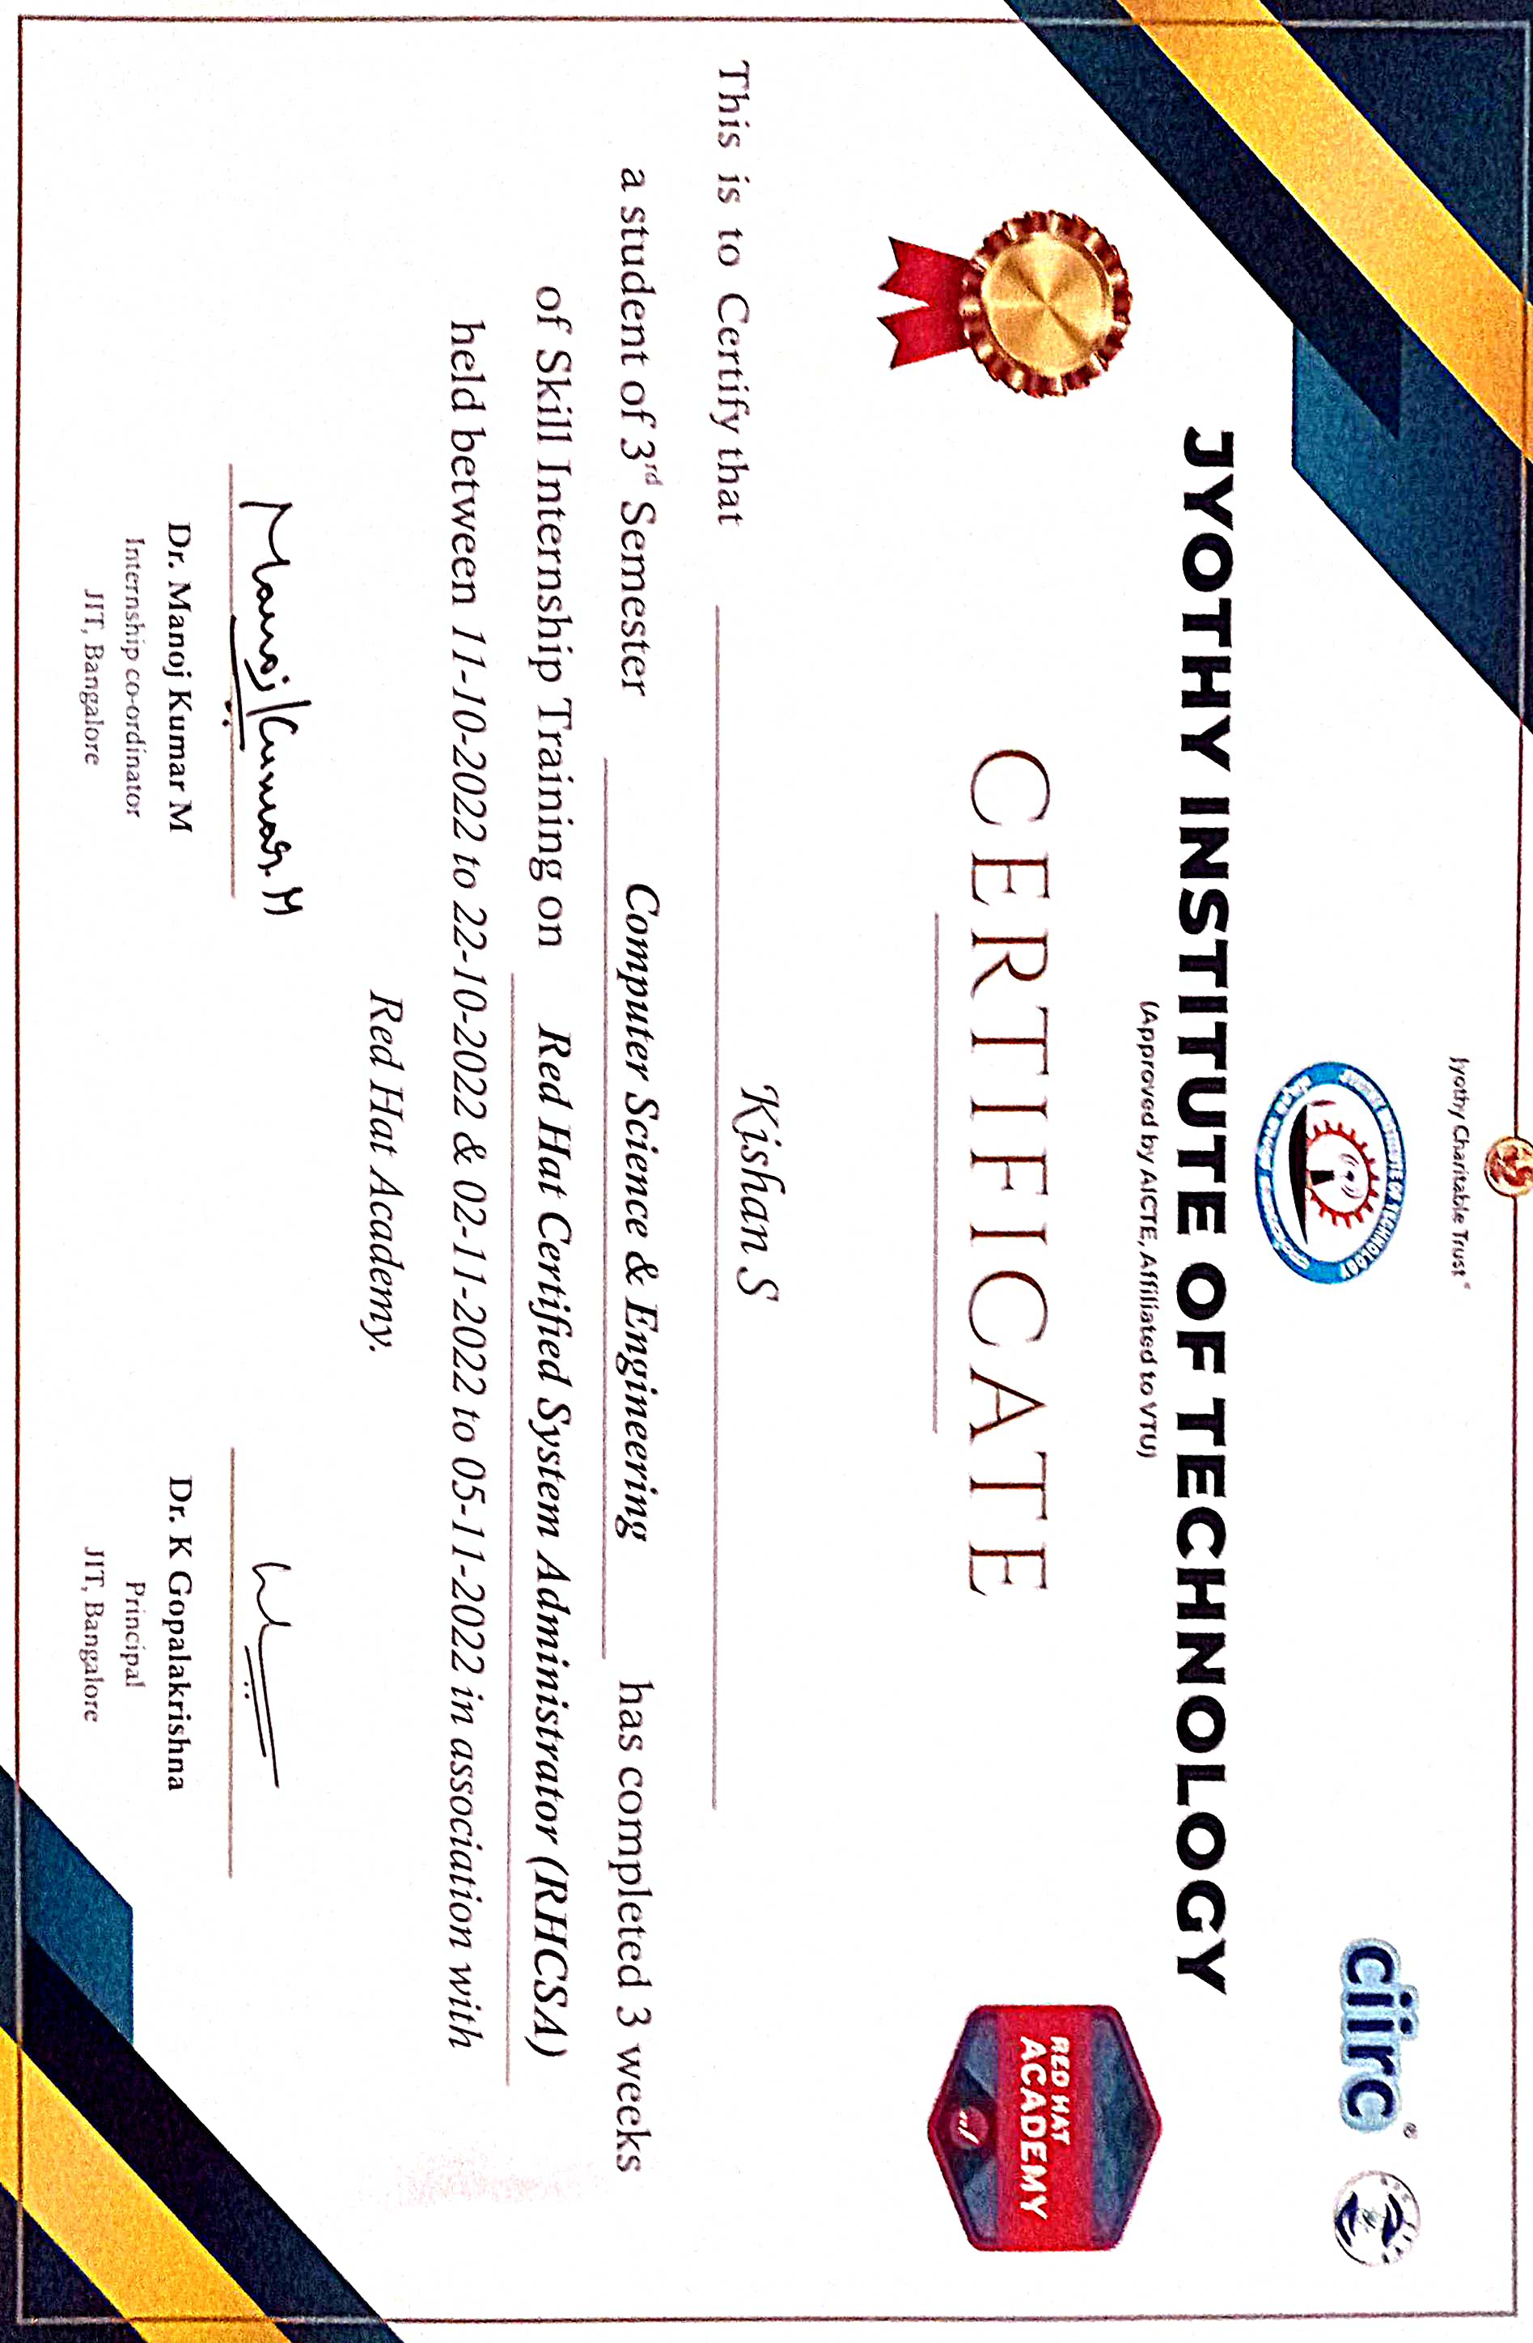



# 

# DECLARATION

I, Kishan S, 4th Semester student of Computer Science and Engineering, Jyothy Institute of Technology, Bangalore - 560 082, declare that the Internship – 21INT49, is successfully completed.

This report is submitted in partial fulfillment of the requirements for award of Bachelor Degree in Computer Science and Engineering, during the academic year 2022-2023.

Date: 17-09-2023 Place: Bangalore

USN: 1JT21CS052

NAME: Kishan S

# ACKNOWLEDGEMENT

This Internship is a result of accumulated guidance, direction and support of several important persons. I take this opportunity to express our gratitude to all, who have helped us to complete the Internship.

I express my sincere thanks to our Principal Dr K. Gopalakrishna, for providing us adequate facilities to undertake this Internship.

I would like to thank Dr. Prabhanjan. S, Head of Dept - CSE, for providing us an opportunity to carry out Internship and for his valuable guidance and support.

I would like to thank Mrs. Madhu, Assistant Professor, Dept of CSE, for guiding us during the course of internship.

I would like to thank all the faculty members of CSE department for the support extended during the internship.

I would like to thank the non-teaching members of the Dept of CSE, for helping us during the Internship.

Last but not the least, I would like to thank my parents and friends without whose constant help, the completion of Internship would have not been possible.

Kishan S [1JT21CS052]

**ABSTRACT**

**The Red Hat Certified Administrator (RHCA)**

It’s a certification program is a comprehensive and globally recognized credential designed for IT professionals seeking to demonstrate their proficiency in managing Red Hat Enterprise Linux (RHEL) environments. This certification encompasses a broad range of skills and knowledge, including system administration tasks, server deployment, security management, and troubleshooting.

The RHCA program equips professionals with the expertise to deploy and manage enterprise-grade solutions using Red Hat technologies. Candidates undergo rigorous training and examination processes that cover a wide spectrum of topics, such as system configuration, storage management, network administration, and automation.

**Internet Of Things (IOT)**

The Internet of Things (IoT) has emerged as a transformative technological paradigm that interconnects physical objects and devices through the internet, enabling them to collect, exchange, and act upon data. This abstract presents a concise overview of IoT, highlighting its key components, applications, challenges, and potential impacts.

IoT encompasses a vast network of devices ranging from everyday objects like home appliances to industrial machinery, wearables, and environmental sensors. These devices are embedded with sensors, processors, and communication capabilities that facilitate data generation, transmission, and analysis. The seamless integration of the physical and digital realms offers unprecedented opportunities for automation, efficiency enhancement, and informed decision-making.

However, the widespread adoption of IoT also presents challenges. Security and privacy concerns arise due to the massive amount of sensitive data being transmitted and stored. Ensuring the integrity of devices and data, as well as safeguarding against unauthorized access, becomes paramount. Interoperability issues between different IoT platforms and devices hinder seamless communication and integration. Additionally, the sheer volume of data generated can overwhelm existing infrastructure, demanding scalable solutions for data storage, processing, and analysis.

In conclusion, IoT stands at the forefront of digital innovation, reshaping how we interact with the world around us. Its potential to enhance efficiency, optimize resource utilization, and enable novel services is undeniable. However, addressing security, privacy, and interoperability challenges is essential for its sustainable growth. As IoT continues to evolve, its impact on industries, economies, and societies at large will be a subject of ongoing research and exploration.

***Red Hat Certified System Administrator***

**Red Hat Certified System Administrator**

**TABLE OF CONTENTS**

|  |  |  |
| --- | --- | --- |
| Sl No | Description | Page No |
| 01 | Introduction | 11-15 |
| 02 | Problem statement | 17 |
| 03 | Work breakdown structure | 19 |
| 04 | Requirements | 21-22 |
| 06 | Screenshots | 24-26 |
| 07 | Projects | 28-32 |
| 08 | Conclusion | 34 |
| 09 | References | 36 |

**List of Figures**

|  |  |  |
| --- | --- | --- |
| Sr No | Description | Page No |
| 01 | Red Hat logo | 11 |
| 02 | Screenshots | 24-26 |
| 03 | Project | 28-32 |

**List of Tables**

|  |  |  |
| --- | --- | --- |
| Sl No | Description | Page No |
| 01 | Work breakdown structure | 20 |

**CHAPTER 1**

**INTRODUCTION**

Red Hat Academy is an educational program offered by Red Hat,a leading global provider of open-source solutions.It is designed to empower students and institutionswith the knowledge and skills needed to excel inthe world of open-source technology.

At its core, Red Hat Academy focuses on training individuals in the use and management of Red Hat's enterprise-grade Linux operating system and other open-source technologies. Through a comprehensive curriculum and hands-on labs, students gain proficiency in Linux administration, cybersecurity, and containerization technologies like Docker and Kubernetes.

Red Hat Academy offers a structured learning path, from basic to advanced levels, making it suitable for students of all skill levels. It provides a bridge between academic knowledge and real-world IT environments, preparing students for careers in fields such as system administration, cloud computing, and DevOps.

Furthermore, Red Hat's reputation in the industry adds value to the program, as it is recognized and respected by many employers globally. Graduates of Red Hat Academy are well-equipped to meet the growing demand for open-source expertise in the IT job market, making it a valuable resource for educational

Figure 1:Red Hat Logo

* 1. **THE IMPORTANCE OF LINUX EXPERTISE**

Linux expertise is of paramount importance in today's technology landscape due to its ubiquity, cost-efficiency, security, stability, and customizability. Linux is not just an operating system; it's a versatile platform that underpins a wide array of devices and systems, from servers and supercomputers to smartphones and IoT devices.

One of the most compelling aspects of Linux is its cost-efficiency. Being open-source and free, it presents an attractive option for organizations aiming to reduce IT expenses. Linux experts play a crucial role in helping organizations harness the benefits of Linux without incurring hefty licensing fees.

Security is another key factor. Linux's strong security features make it a preferred choice for critical applications. Linux experts are instrumental in configuring, maintaining, and monitoring secure systems. They keep systems up to date with security patches, implement access controls, and respond to security incidents, safeguarding data and operations.

Linux's reputation for stability and uptime is vital for businesses reliant on continuous operation. Linux experts are adept at setting up and managing resilient infrastructures, minimizing downtime, and ensuring smooth, uninterrupted business operations.

Customizability is a hallmark of Linux. Linux experts can tailor systems to meet unique requirements, optimizing performance, and efficiency. Whether it's fine-tuning a server for high performance or customizing a desktop environment for user productivity, Linux expertise is indispensable.

With Linux's expansive open-source ecosystem, Linux experts can integrate a wide array of tools, libraries, and software into their solutions. The Linux community is a valuable resource for troubleshooting and problem-solving, further highlighting the significance of Linux expertise.

Overall, Linux expertise is not only about mastering an operating system; it's about empowering organizations with versatile, cost-effective, secure, and highly customizable solutions, all of which are essential in today's technology-driven world. Additionally, Linux expertise opens up diverse career opportunities in fields like system administration, cybersecurity, cloud computing, and software development, making it a valuable skill set for professionals in the IT industry.

* 1. **An overview of RHCSA certification**

The Red Hat Certified System Administrator (RHCSA) certification is a prestigious credential in the realm of Linux system administration, particularly centered on Red Hat Enterprise Linux (RHEL). This certification verifies your competence in fundamental tasks crucial for maintaining and managing Linux-based systems effectively.

To earn RHCSA certification, candidates must pass the hands-on RHCSA exam (EX200), where they demonstrate practical proficiency in a controlled environment. This exam evaluates essential skills such as system configuration, user and group management, file and directory manipulation, permissions and security settings, package management, network configuration, shell scripting, and system troubleshooting.

In summary, RHCSA certification serves as a solid foundation for Linux system administrators and is a key stepping stone toward establishing expertise in Red Hat technologies, opening doors to a multitude of career prospects in the ever-expanding field of Linux and open-source technologies.

**1.3** **Objectives of Red Hat Certified System Administrator (RHCSA)**

The Red Hat Certified System Administrator (RHCSA) certification is designed to validate and enhance the skills and knowledge of IT professionals in the field of Linux system administration. Its objectives and scope are defined to ensure that certified individuals possess the competency needed to effectively manage and maintain Red Hat Enterprise Linux systems. Below, we outline the primary objectives and the scope of the RHCSA certification:

**Objectives:**

1. System Configuration: RHCSA candidates are expected to demonstrate the ability to configure and manage various aspects of a Red Hat Enterprise Linux system. This includes setting up network configurations, managing users and groups, configuring services, and establishing system parameters.
2. File System Management: Proficiency in managing the file system is a crucial aspect of the RHCSA certification. Candidates should be capable of creating, modifying, and deleting files and directories, setting permissions, and managing storage

3. User and Group Administration: RHCSA certification assesses candidate’s ability to manage user accounts, groups, and authentication settings effectively. This includes creating and managing user accounts, changing passwords, and understanding user-level security.

4. Security: Security is a top priority in system administration. RHCSA candidates must demonstrate the capability to secure systems by implementing basic security measures, including firewall configuration, access control, and the use of cryptographic tools.

5. Package Management: Linux systems rely on package management for software installation and updates. RHCSA certification covers the use of package managers, such as YUM (Yellowdog Updater, Modified), for software management.

6. Service Management: Candidates are expected to manage system services, ensuring they start at boot, stop as needed, and are configured correctly. Understanding and using systemd is a key component of this objective.

7. Troubleshooting and Diagnostics: Proficient troubleshooters are invaluable in IT. RHCSA certification evaluates candidates' ability to diagnose and rectify system issues effectively. This includes identifying and resolving boot issues, network connectivity problems, and system performance bottlenecks.

**1.4 FUTURE SCOPE AND ENCHANCEMENT**

The future scope and enhancement potential of Red Hat appear promising, reflecting the dynamic landscape of open-source technologies and the ever-evolving needs of organizations worldwide. Red Hat, a leading force in the open-source community, is poised to play a pivotal role in shaping the IT landscape of tomorrow.

As the demand for cloud-native solutions, containerization, and hybrid cloud environments continues to surge, Red Hat's OpenShift Container Platform stands as a beacon of innovation. The platform's Kubernetes-based architecture, coupled with Red Hat's expertise in enterprise-grade solutions, positions it as a go-to choice for organizations seeking scalable, flexible, and secure container orchestration.

Moreover, Red Hat's commitment to open-source principles ensures that its solutions remain adaptable and extensible. With a vast ecosystem of partners and contributors, Red Hat can harness the collective power of the open-source community to drive continuous improvement. This collaboration fosters the development of innovative solutions that cater to emerging trends, such as edge computing, serverless architectures, and AI/ML-driven applications.

Red Hat's focus on security and compliance is also well-aligned with the evolving threat landscape and regulatory requirements. By integrating advanced security features and proactive vulnerability management into its solutions, Red Hat remains at the forefront of safeguarding IT infrastructures against emerging threats.

The future enhancement of Red Hat's offerings is likely to revolve around:

**1. Edge Computing**: As edge computing gains prominence in IoT and real-time applications, Red Hat is poised to provide solutions that enable organizations to manage and secure distributed edge environments effectively.

**2. Artificial Intelligence and Machine Learning (AI/ML)**: Red Hat's commitment to AI/ML innovation will likely result in solutions that streamline the deployment and management of AI/ML workloads on hybrid cloud infrastructures.

**3. Serverless Computing:** The adoption of serverless architectures is on the rise. Red Hat's involvement in serverless technologies will lead to the development of serverless platforms and tools for streamlined application deployment and management.

**4. Hybrid Cloud Integration:** Red Hat will continue to enhance its capabilities for seamlessly integrating on-premises data centers with public and private cloud environments, enabling organizations to embrace hybrid cloud strategies more effectively.

**5. Automation and DevOps:** Red Hat's Ansible Automation Platform will see further advancements, simplifying automation workflows and enhancing collaboration between development and operations teams.

**CHAPTER 2**

**PROBLEM STATEMENT**

**2.1 Problem Statement:**

Many organizations face the challenge of efficiently managing and maintaining their complex IT infrastructures, often comprising a mix of different operating systems, applications, and services. This diversity can lead to increased operational overhead, security vulnerabilities, and difficulties in ensuring standardization and compliance.

**2.2 Problem Solution:**

Organizations can address this challenge by implementing Red Hat's comprehensive suite of open-source solutions and management tools. Red Hat provides a unified platform for managing diverse IT environments, including Red Hat Enterprise Linux, OpenShift for container orchestration, and Ansible for automation. By adopting Red Hat's solutions, organizations can achieve standardization, automation, and enhanced security across their IT landscape, reducing operational complexity and improving efficiency. This unified approach not only simplifies system administration but also enhances overall system reliability and compliance, ensuring that IT environments are well-prepared to meet the demands of modern business operations.

**CHAPTER 3**

**WORK BREAKDOWN STRUCTURE**

|  |  |  |
| --- | --- | --- |
| Week No | Day No | Details of work done |
| Week 1 | Day 1 | Introduction to RHCSA, Installing VMware/VirtualBox |
|  |  |  |
|  | Day 2 | Created a RHEL account, Learning theory on basis of RedHat. |
|  |  |  |
|  | Day 3 | Creating and executing bash shell scripts |
|  |  |  |
|  | Day 4 | Debugging other tools of that OS |
|  |  |  |
|  | Day 5 | Learning The Navigation of the OS  Ex: Basic Commands like ls, cd.. etc |
|  |  |  |
|  | Day 6 | Exploring the Red hat Operating System |
|  |  |  |
|  | Day 7 | Last day of the week: revising the content of the week |
|  |  |  |
| Week 2 | Day 1 | Learning some more commands on OS |
|  |  |  |
|  | Day 2 | Learning about the basic file hierarchy of OS |
|  |  |  |
|  | Day 3 | Again a few more theory was learnt |
|  |  |  |
|  | Day 4 | Managing selinux security |
|  |  |  |
|  | Day 5 | Learning to create a swap partition,managing logical volumes |
|  |  |  |
|  | Day 6 | Last day of the week: revising the content of the week |
|  |  |  |
| Week 3 | Day 1 | Accessing network-attached storage |
|  |  |  |
|  | Day 2 | Systemctl,rebbot,systemctl poweroff |
|  |  |  |
|  | Day 3 | Managing server firewalls,configuring the firewalls |
|  |  |  |
|  | Day 4 | Establishing connection between servers, Learning more about linking |
|  |  |  |
|  | Day 5 | Started an Project on Transferring files using protocols |
|  |  |  |
|  |  | Presenting that project to the guide of the internship,  submitting the report of the project at last. |
|  | Day 6 |  |
|  |  |  |

**CHAPTER 4**

**REQUIREMENTS**

**Hardware and Software Requirements:**

**Hardware Requirements:**

For the hardware requirement , we needed :

**1. Computer**: We need a computer or laptop with sufficient processing power, memory, and storage to comfortably run a virtualization software like VirtualBox or VMware Workstation.

**2. Memory (RAM):** A minimum of 4 GB of RAM is recommended, but having 8 GB or more is preferable to run virtual machines smoothly.

**3. Processor:** A multi-core processor with support for hardware virtualization (e.g., Intel VT-x or AMD-V) is essential for running virtual machines effectively.

**4. Internet Connection**: An internet connection is needed for downloading software, updates, and resources during your RHCSA preparation.

**Software Requirements:**

**1. Operating System**: We can choose to use any operating system as your host machine (e.g., Windows, Linux, macOS).

**2. Virtualization Software**: You'll need virtualization software like VirtualBox, VMware Workstation to create and manage virtual machines.

**3. Linux Distributions**: We primarily worked with Red Hat Enterprise Linux (RHEL) during our RHCSA preparation.

**Functional and Non-Functional Requirements**

**Functional requirements:**

The Red Hat Certified System Administrator (RHCSA) certification primarily focuses on assessing your functional skills related to Linux system administration,so some of the functional and non functional requirements are :

1. **1 .System Configuration**: Candidates must be able to configure and manage various system settings, such as hostname, time and date, network configurations, and system logging.
2. **2. User and Group Management**: Proficiency in creating, modifying, and managing user and group accounts, including setting user passwords, group memberships, and user access controls.

**3.File and Directory Operations**: Competence in basic file and directory operations, such as creating, modifying, copying, moving, and deleting files and directories.

**4.Permissions and Security**: Understanding and implementation of file and directory permissions, as well as security practices to protect system resources and data.

**5. Package Installation and Management**: Knowledge of package management tools to install, update, and remove software packages.

**6. Networking Configuration**: Configuration and troubleshooting of network interfaces, routes, DNS settings, and firewall rules.

**7. Basic Shell Scripting**: Ability to create and execute basic shell scripts to automate tasks and system administration.

**8. Troubleshooting**: Proficiency in identifying and resolving common system issues, system diagnostics, and system recovery procedures.

**Non-functional requirements:**

**1.Time Constraints**: Candidates are typically given a specific time frame to complete the RHCSA exam tasks, emphasizing the importance of efficiency and time management.

**2.Performance**: While RHCSA primarily focuses on functional skills, the efficient completion of tasks within the allotted time is crucial, highlighting the non-functional aspect of performance.

**3.Accessibility**: The exam should be accessible to all candidates, including those with disabilities, and accommodations may be provided as needed.

**4.Security**: The RHCSA exam environment and procedures must adhere to strict security standards to prevent cheating or unauthorized access to exam materials.

**CHAPTER 6**

**SCREENSHOTS**

Here are few List of Files and Screenshots of Servera:

Figure 2.1: servera

Figure2.2: servera

Here is a screenshot of SELinux and Cron Job:

Figure 2.3: SELinux

Figure 2.4: Cron Job

Here are few Screenshots of RHCA Login:

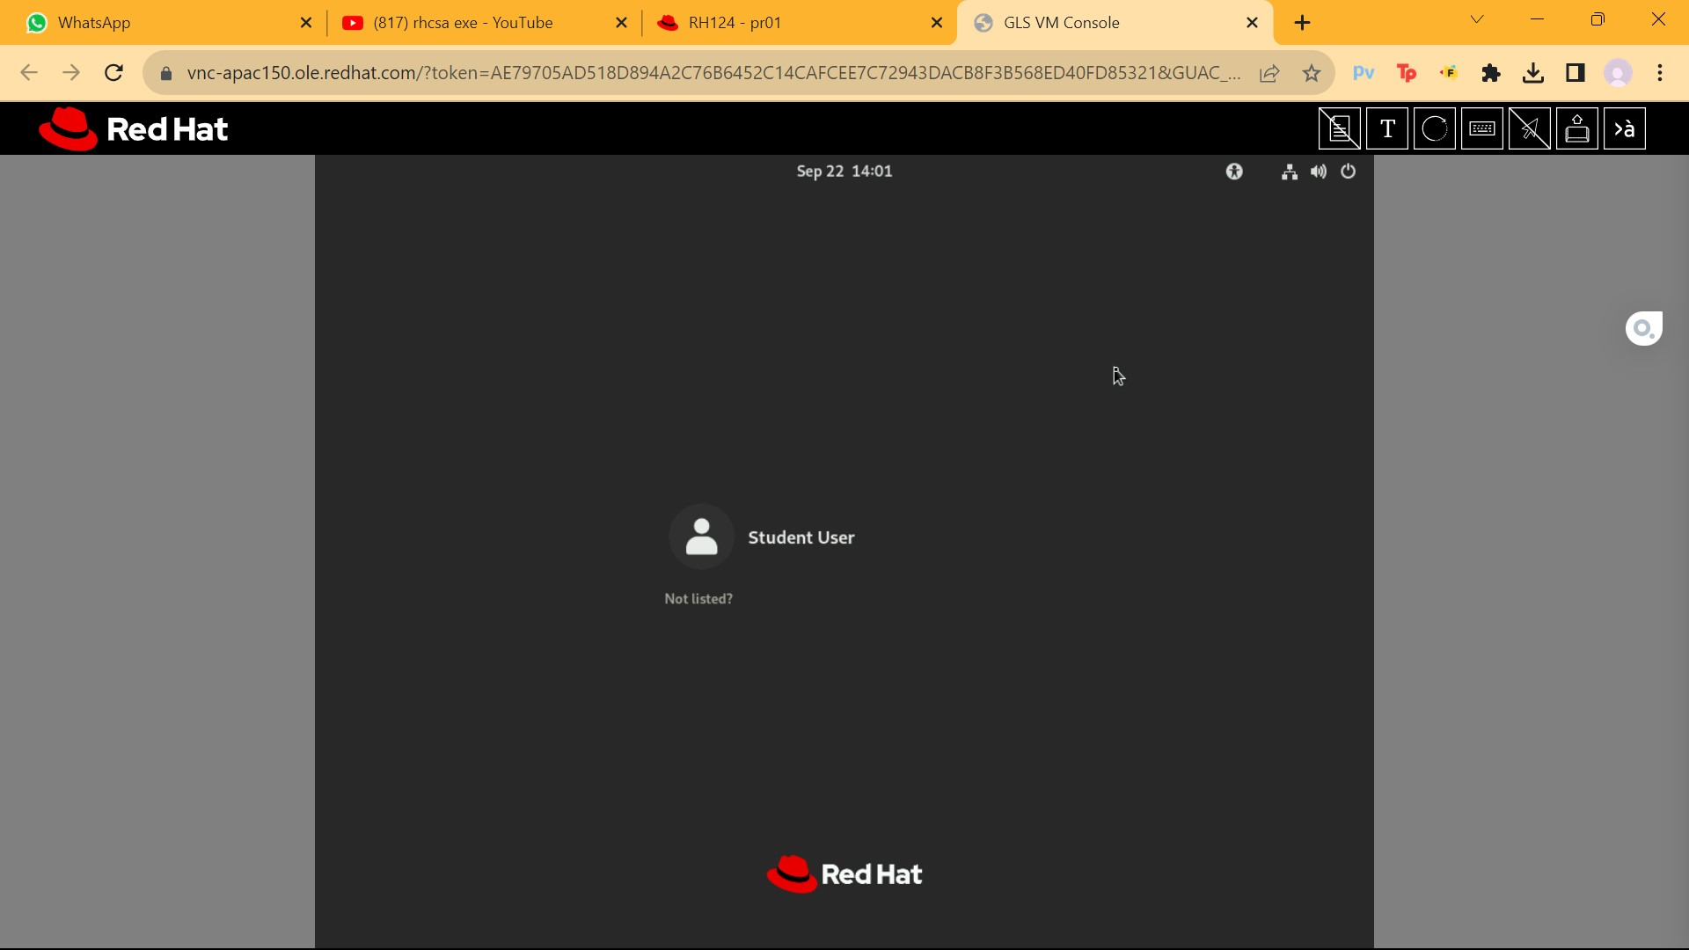

Figure 2.6: RHCA Login

Figure 2.7: RHCA command window

**CHAPTER 8**

**PROJECTS**

1. Generate SSH keys for the user student on serverb. Do not protect the private key with a passphrase.

From workstation, open an SSH session to serverb as student.



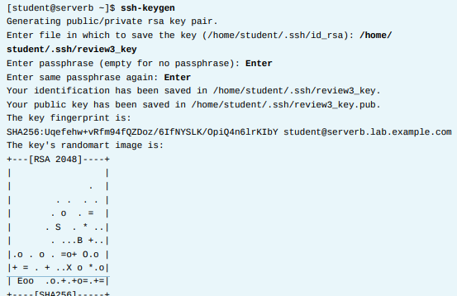

Figure 3: severb commands

1. On servera, configure the user student to accept logins authenticated by the SSH key pair you created for the user student on serverb. The user student on serverb should be able to log in to servera using SSH without entering a password.

Use the ssh-copy-id command to export the public key /home/student/.ssh/review3_key.pub from servera to serverb.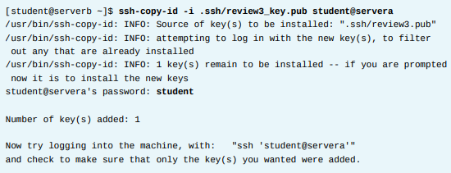

Figure 4.1: ssh-copy-id command

Use the ssh command to confirm that you can log in to servera from serverb as student using the SSH private key /home/student/.ssh/review3_key without being prompted for the password.



Figure 4.2: ssh command

Log out of servera.

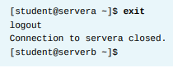

Figure 4.3: Logging out of servera

1. Use the yum command to enable the default module stream for the module python36 and install all the provided packages from that stream, on serverb.

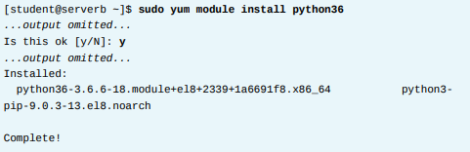

Figure 5: yum command

1. On serverb, restore the original network settings by activating the original network connection

Go back to the console and use the nmcli command to activate the original network profile.



Figure 6.1: nmcli command

The name of the original connection profile might differ on your serverb. If so,replace the name show in this solution with the name you actually saw on your system. You should be able to find it with nmcli connection show if you have forgotten it.

From workstation, open an SSH session to serverb as student to ensure that the original network settings are successfully activated.



Figure 6.2: ssh severb command

Log out of serverb and exit all but one terminal on workstation

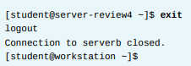

Figure 6.3: Log out of severb

1. On serverb, locate all the files of 100 bytes in size. Record the absolute paths to all of these files in the /review5-disk/review5-size.txt.

Use the -size option with the find command to locate all the files that are of 100 bytes in size. Redirect all the errors of the find command to /dev/null.

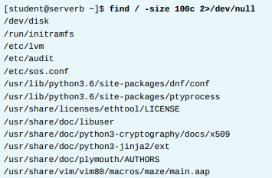

Figure 7.1: find command

The preceding output may vary in your system depending on the number of files of 100 bytes in size in your system. Note the absolute paths to all the files from the preceding output.

Create the /review5-disk/review5-size.txt text file. Record the absolutepaths to all the files of 100 bytes in size, as determined in the preceding step, in the /review5-disk/review5-size.txt text file. You may use the sudo vim /review5-disk/review5-size.txt command to create the text file. Type :wq! from the command mode in vim to save the changes and quit from the file. The / review5-disk/review5-size.txt text file should contain the absolute path to the review5-size file among other paths.



Figure 7.2: output omitted

Log out of serverb.

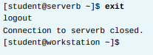

Figure 7.3: severb log out

**CHAPTER 9**

**CONCLUSION**

In conclusion, Red Hat is a remarkable company that has significantly shaped the world of open-source technology. Its commitment to open-source principles, innovation, and customer satisfaction has made it a trusted partner for countless organizations around the globe. Red Hat's product portfolio, including Red Hat Enterprise Linux, OpenShift, and Ansible, offers robust solutions that address the ever-evolving challenges of the IT industry. One of Red Hat's standout features is its dedication to collaboration and adaptability. By embracing emerging technologies like containerization, Kubernetes, and hybrid cloud solutions, Red Hat stays at the forefront of industry trends. Their OpenShift Container Platform, for instance, exemplifies their commitment to providing tools that empower organizations to excel in the era of cloud-native computing.

Additionally, Red Hat places a strong emphasis on security and compliance, ensuring that their solutions meet the highest standards of cybersecurity. Their proactive approach to vulnerability management, notably through Red Hat Insights, underscores their commitment to keeping systems secure. Red Hat's contributions extend beyond technology, with their certification programs such as RHCSA and RHCE helping individuals validate their skills and advance their careers. Redhat-RHCSA 2022-23 Dept. of ISE 1 In essence, Red Hat's journey is a testament to innovation, collaboration, and a steadfast dedication to open-source principles. In a rapidly changing digital landscape,

Red Hat continues to be a reliable partner, equipping organizations with the tools and expertise needed to thrive. Whether it's in the realms of cloud computing, containerization, or open-source technologies, Red Hat remains a driving force, helping organizations unlock the full potential of their IT infrastructures.

**CHAPTER 10**

**REFERENCES**

* [RHCE 8 | EX294 Complete Course Single Video | Ansible Tutorial | Tech Arkit - YouTube](https://www.youtube.com/watch?v=8rgGNIKfyfI)
* <https://www.google.com/>
* [www.redhat.com](http://www.redhat.com)
* Open AI – ChatGPT

***Internet of Things Fundamentals***

**Internet of Things Fundamentals**

**Table Of Contents**

|  |  |  |
| --- | --- | --- |
| Sl No | Description | Page No |
| 01 | Organization and Department | 41-43 |
| 02 | Introduction | 44-47 |
| 03 | Details of Internship | 48-55 |
| 04 | Scope of IoT | 56-58 |
| 05 | Steps to build a project using Arduino | 59-61 |
| 06 | Mini Project | 62-66 |
| 07 | Conclusion | 67-68 |
| 08 | References | 69-71 |

**List of Figures**

|  |  |  |
| --- | --- | --- |
| Sl No | Description | Page No |
| 01 | Tequed lab logo | 42 |
| 02 | IoT Design Flow | 47 |
| 03 | Arduino uno | 53 |
| 04 | ESP8266 | 53 |
| 05 | IR sensor | 54 |
| 06 | DHT sensor | 54 |
| 07 | PIR sensor | 54 |
| 08 | DC motor | 55 |
| 09 | LCD display | 55 |
| 10 | RF technology | 55 |
| 11 | Smart Specs | 63 |
| 12 | Circuit diagram | 64 |

**CHAPTER 1**

**ORGANIZATION AND DEPARTMENT**

**1.1 ABOUT THE ORGANIZATION**



Figure 1 : Tequed lab Logo

Tequed Labs is a research and development centre and educational institute based in Bangalore started by Mr Aditya S K and Mr Supreeth Y S. Tequed Labs are focused on providing quality education on latest technologies and develop products which are of great need to the society and involve distribution and sales of latest electronic innovation products developed all over the globe to our customers. Also run a project consultancy where they undertake various projects from wide range of companies and assist them technically and build products and provide services to them. And are continuously involved in research about futuristic technologies and finding ways to simplify them for our students.

**1.2 WORK CULTURE:**

At Tequed Labs, a vibrant and innovative work culture prevails. The organization fosters an environment that encourages creativity, collaboration, and intellectual curiosity. Employees are not only committed to their work but also dedicated to nurturing the spirit of innovation and learning. This culture of continuous improvement and exploration forms the backbone of Tequed Labs' success.

**1.3 SERVICES:**

Tequed Labs offers a diverse range of services that cater to both the educational and industrial sectors:

a) Educational Services: Tequed Labs provides students with hands-on learning experiences that bridge the gap between theoretical knowledge and practical application. Their educational programs are designed to empower students with the skills needed for real-world challenges.

b) Project Consultancy: The organization undertakes a wide array of projects from various companies, offering technical expertise to assist in product development and service provision. Tequed Labs' team of experts collaborates closely with clients to bring their innovative ideas to life.

**1.4 CLIENTS AND PRODUCTS:**

Tequed Labs boasts a robust portfolio of clients and products, reflecting their commitment to innovation and excellence. Some of their esteemed clients include multinational corporations, startups, and research institutions. The organization has been instrumental in the development of cutting-edge products across multiple industries, ranging from electronics and telecommunications to healthcare and automotive.

Through their unwavering dedication to research and development, Tequed Labs has contributed significantly to the creation of groundbreaking products and services that have left a lasting impact on the technology landscape.

**CHAPTER 2**

**INTRODUCTION**

**2.1 USES OF IOT**

We use IoT (Internet of Things) for several technical reasons:

1. **Data Collection**: IoT devices can collect vast amounts of data from sensors, cameras, and other sources. This data can provide valuable insights and inform decision-making in various fields such as industry, agriculture, and healthcare.
2. **Automation**: IoT enables automation by allowing devices to communicate and make decisions based on data. For instance, smart thermostats can adjust temperatures based on occupancy and weather forecasts, improving energy efficiency.
3. **Remote Monitoring and Control**: IoT allows remote monitoring and control of devices and systems. This is crucial in scenarios where physical access is limited or unsafe, such as in industrial settings or in the management of critical infrastructure.
4. **Efficiency**: IoT helps optimize processes and resource utilization. For example, in agriculture, IoT sensors can determine when and where irrigation is needed, conserving water and improving crop yields.
5. **Predictive Maintenance**: IoT sensors can monitor the condition of machines and equipment in real-time, enabling predictive maintenance. This prevents unexpected breakdowns, reduces downtime, and saves costs.
6. **Enhanced User Experience**: In consumer applications like smart homes, IoT provides a seamless and convenient user experience. Users can control devices remotely, receive alerts, and customize settings through mobile apps or voice assistants.
7. **Scalability**: IoT systems can scale easily to accommodate a large number of devices and sensors. This scalability is crucial for applications like smart cities, where numerous devices need to communicate and work together.
8. **Energy Efficiency**: IoT can help conserve energy by optimizing lighting, heating, and cooling systems based on occupancy and environmental conditions.
9. **Real-time Feedback**: IoT systems can provide real-time feedback and alerts. For instance, in healthcare, wearable IoT devices can monitor a patient's vital signs and send alerts to medical professionals in case of emergencies.
10. **Improved Decision-Making**: The data collected by IoT devices can be processed through analytics and machine learning algorithms to extract actionable insights. This enables better decision-making and more informed strategies.
11. **Environmental Monitoring**: IoT is crucial for environmental monitoring, tracking parameters like air quality, water quality, and climate conditions. This data is vital for managing and mitigating environmental issues.
12. **Safety and Security**: IoT can enhance safety and security through applications like smart surveillance, access control systems, and fire detection.

In summary, IoT is employed for its ability to connect, collect, and process data from a wide range of devices and sensors, ultimately leading to improved efficiency, automation, and enhanced capabilities in various technical domain.

**2.2 IOT DESIGN FLOW**

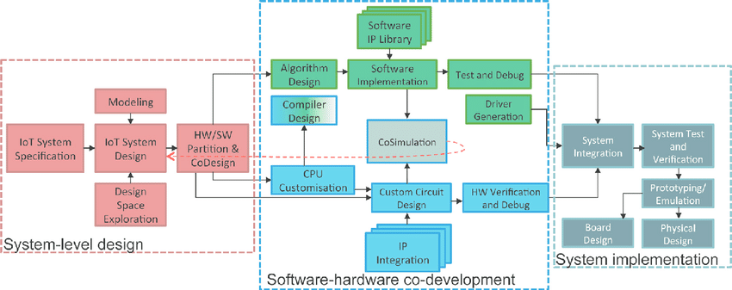

Figure 2 : IoT design flow

**2.3 OBJECTIVES**

The objectives of IoT (Internet of Things) can vary depending on the specific application and context, but some common objectives include:

1**. Efficiency**: Improve operational efficiency by automating processes and reducing manual intervention. IoT can optimize resource usage, reduce waste, and streamline workflows.

2. **Cost Reduction:** Achieve cost savings through better resource management, predictive maintenance, and energy efficiency. IoT can help organizations lower operational and maintenance expenses.

3. **Data Insights:** Collect and analyze data from connected devices to gain actionable insights. IoT enables data-driven decision-making and helps organizations make informed choices.

4. **Remote Monitoring and Control:** Enable remote monitoring and control of devices and systems, reducing the need for physical presence and enhancing accessibility and responsiveness.

5. **Enhanced User Experience:** Enhance user experiences through convenience and personalization. IoT applications in smart homes, wearables, and consumer devices aim to improve daily life.

6. **Safety and Security:** Improve safety and security through applications like surveillance, access control, and alert systems. IoT can help prevent accidents and respond quickly to emergencies.

7. **Environmental Impact**: Reduce environmental impact by optimizing resource usage, reducing energy consumption, and enabling more sustainable practices, especially in industries like agriculture and energy management.

8. **Scalability:** Create scalable solutions that can grow with the increasing number of connected devices and users, ensuring long-term viability and adaptability.

9. **Interoperability**: Foster interoperability between different IoT devices and platforms, allowing devices from various manufacturers to work together seamlessly.

10. **Predictive Maintenance**: Implement predictive maintenance strategies to reduce downtime and extend the lifespan of equipment and machinery.

11. **Smart Cities**: Create smarter and more efficient urban environments by optimizing traffic management, waste collection, and public services.

12. **Supply Chain Optimization**: Optimize supply chains by tracking the location and condition of goods in real-time, reducing losses, and improving delivery accuracy.

Overall, the objectives of IoT encompass a wide range of goals, from improving efficiency and reducing costs to enhancing safety, security, and sustainability, while also opening doors for innovation and new business opportunities. The specific objectives depend on the use case and industry in which IoT technology is applied.

**2.4 SCOPE**

The scope of IoT (Internet of Things) is vast and continually expanding. It is used in sectors like manufacturing, Agriculture, Healthcare, Transportation, Retail, Waste and Water Management, Power Distribution.,

It is essential for achieving high productivity, efficiency, a safe working environment, and low carbon emission in industry.

**CHAPTER 3**

**DETAILS OF INTERNSHIP**

* 1. **LITERATURE SURVEY**

# Edge Computing: Vision and Challenges

The proliferation of Internet of Things (IoT) and the success of rich cloud services have pushed the horizon of a new computing paradigm, edge computing, which calls for processing the data at the edge of the network. Edge computing has the potential to address the concerns of response time requirement, battery life constraint, bandwidth cost saving, as well as data safety and privacy. In this paper, we introduce the definition of edge computing, followed by several case studies, ranging from cloud offloading to smart home and city, as well as collaborative edge to materialize the concept of edge computing. Finally, we present several challenges and opportunities in the field of edge computing, and hope this paper will gain attention from the community and inspire more research in this direction.

**Published in:**[IEEE Internet of Things Journal](https://ieeexplore.ieee.org/xpl/RecentIssue.jsp?punumber=6488907) ( Volume: 3, [Issue: 5](https://ieeexplore.ieee.org/xpl/tocresult.jsp?isnumber=7563473&punumber=6488907), October 2016)

# Integrated Sensing and Communication Signals Toward 5G-A and 6G: A Survey

Integrated sensing and communication (ISAC) has the advantages of efficient spectrum utilization and low hardware cost. It is promising to be implemented in the fifth-generation-advanced (5G-A) and sixth-generation (6G) mobile communication systems, having the potential to be applied in intelligent applications requiring both communication and high-accurate sensing capabilities. As the fundamental technology of ISAC, ISAC signal directly impacts the performance of sensing and communication. This article systematically reviews the literature on ISAC signals from the perspective of mobile communication systems, including ISAC signal design, ISAC signal processing, and ISAC signal optimization. We first review the ISAC signal design based on 5G, 5G-A, and 6G mobile communication systems. Then, radar signal processing methods are reviewed for ISAC signals, mainly including the channel information matrix method, spectrum lines estimator method, and super-resolution method. In terms of signal optimization, we summarize peak-to-average power ratio (PAPR) optimization, interference management, and adaptive signal optimization for ISAC signals. This article may provide the guidelines for the research of ISAC signals in 5G-A and 6G mobile communication systems.

**Published in:**[IEEE Internet of Things Journal](https://ieeexplore.ieee.org/xpl/RecentIssue.jsp?punumber=6488907) ( Volume: 10, [Issue: 13](https://ieeexplore.ieee.org/xpl/tocresult.jsp?isnumber=10159464&punumber=6488907), 01 July 2023)

# 3) An Enhanced AI-Based Network Intrusion Detection System Using Generative Adversarial Networks

As communication technology advances, various and heterogeneous data are communicated in distributed environments through network systems. Meanwhile, along with the development of communication technology, the attack surface has expanded, and concerns regarding network security have increased. Accordingly, to deal with potential threats, research on network intrusion detection systems (NIDSs) has been actively conducted. Among the various NIDS technologies, recent interest is focused on artificial intelligence (AI)-based anomaly detection systems, and various models have been proposed to improve the performance of NIDS. However, there still exists the problem of data imbalance, in which AI models cannot sufficiently learn malicious behavior and thus fail to detect network threats accurately. In this study, we propose a novel AI-based NIDS that can efficiently resolve the data imbalance problem and improve the performance of the previous systems. To address the aforementioned problem, we leveraged a state-of-the-art generative model that could generate plausible synthetic data for minor attack traffic. In particular, we focused on the reconstruction error and Wasserstein distance-based generative adversarial networks, and autoencoder-driven deep learning models. To demonstrate the effectiveness of our system, we performed comprehensive evaluations over various data sets and demonstrated that the proposed systems significantly outperformed the previous AI-based NIDS.

**Published in:**[IEEE Internet of Things Journal](https://ieeexplore.ieee.org/xpl/RecentIssue.jsp?punumber=6488907) ( Volume: 10, [Issue: 3](https://ieeexplore.ieee.org/xpl/tocresult.jsp?isnumber=10024910&punumber=6488907), 01 February 2023)

# 4) IoT, Big Data, and Artificial Intelligence in Agriculture and Food Industry

Internet of Things (IoT) results in a massive amount of streaming data, often referred to as “big data,” which brings new opportunities to monitor agricultural and food processes. Besides sensors, big data from social media is also becoming important for the food industry. In this review, we present an overview of IoT, big data, and artificial intelligence (AI), and their disruptive role in shaping the future of agri-food systems. Following an introduction to the fields of IoT, big data, and AI, we discuss the role of IoT and big data analysis in agriculture (including greenhouse monitoring, intelligent farm machines, and drone-based crop imaging), supply chain modernization, social media (for open innovation and sentiment analysis) in food industry, food quality assessment (using spectral methods and sensor fusion), and finally, food safety (using gene sequencing and blockchain-based digital traceability). A special emphasis is laid on the commercial status of applications and translational research outcomes.

**Published in:**[IEEE Internet of Things Journal](https://ieeexplore.ieee.org/xpl/RecentIssue.jsp?punumber=6488907) ( Volume: 9, [Issue: 9](https://ieeexplore.ieee.org/xpl/tocresult.jsp?isnumber=9762554&punumber=6488907), 01 May 2022)

* 1. **TOOLS**
* Sensors are the devices that convert any physical signal into electrical signal.
* They are INPUT devices.
* They are of 2 types namely ACTIVE sensors and PASSIVE sensors.
* Sensors that require an external power source to operate are called active sensors.
* Sensors that do not require an external power source to operate are called passive sensors.
* ***ARDUINO UNO***

Arduino Uno is an open-source microcontroller board based on the processor ATmega328P. There are 14 digital I/O pins, 6 analog inputs, a USB connection, a power jack, an ICSP header, and a reset button. It contains all the necessary modules needed to support the microcontroller. Just plug it into a computer with a USB cable or power it with an adapter to get started. You can experiment with your Arduino without worrying too much about it. In the event of a worst-case scenario, you could buy a new one as the Uno is very economical compared to other boards like raspberry pi, STM, etc.

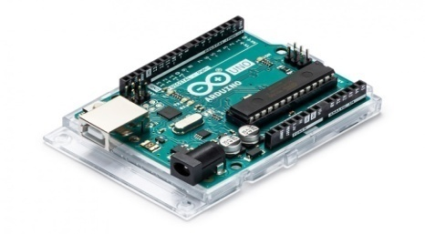

Figure 3 : aurdino uno

* ***ESP8266 CH340 NodeMCU***

**NodeMCU ESP8266** is an open-source Lua based firmware and development board specially targeted for IoT based applications. It includes firmware that runs on the **ESP8266** Wi-Fi SoC from Espressif Systems and hardware which is based on the [ESP-12](https://quartzcomponents.com/products/esp8266-esp12-smt-board) module, and like this, it can also be programmed using [Arduino IDE](https://www.arduino.cc/en/Main/Software) and can act as both WiFi Hotspot or can connect to one. It has one Analog Input Pin, 16 Digital I/O pins along with the capability to connect with serial communication protocols like SPI, UART, and I2C. NodeMCU has 128 KB RAM and 4MB of Flash memory to store data and programs. Its high processing power with in-built Wi-Fi / Bluetooth and Deep Sleep Operating features make it ideal for IoT projects. Its applications include prototyping for IoT devices, low powered battery-operated applications, and projects requiring I/O interface with Bluetooth and WiFi capabilities.

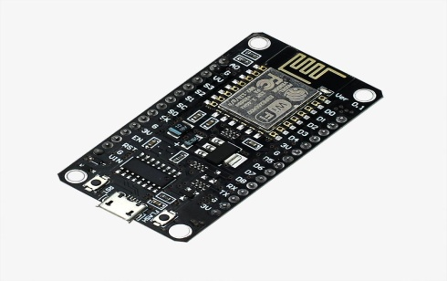

**Figure 4 : esp8266**

* **SENSORS**

IoT sensors are pieces of hardware that detect changes in an environment and collect data. They’re the pieces of an IoT ecosystem that bridge the digital world to the physical world. IoT sensors may detect things like temperature, pressure, and motion, and if they are connected to a network, they share data with the network.

Some of the sensors used in IoT are as follows :

1. 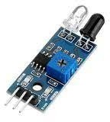**IR sensor**

Figure 5 : IR sensor

IR sensor is interfaced with Node MCU to detect if any object(obstacle) is present in front of the sensor.If there is any object present then the internally built LED on the node MCU will glow and if there is no obstacle then the LED will remain in the OFF state.

1. **DHT sensor**

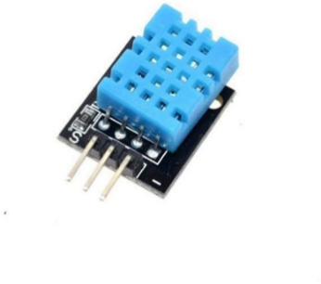

Figure 6 : DHT sensor

The DHT sensors are of 2 parts namely a capacitive humidity sensor and a thermistor .It also consists of a small chip that converts analog signals into digital signals and gives digital output of Temperature and Humidity .This digital signal is easy to read by the controller .

1. **PIR sensor**



Figure 7 : PIR sensor

PIR sensor detects a human being moving around within approximately 10m from the sensor. This is an average value, as the actual detection range is between 5m and 12m.PIR are fundamentally made of a pyro electric sensor, which can detect levels of infrared radiation.

* **ACTUATOR**

Actuators are the workhorses of the Internet of Things and enable the automation or remote control of a wide range of processes in sectors that include consumer, industrial, healthcare, and transportation. This short article explains the role of actuators in IoT and outlines the different types of actuators that are used.

Some of the actuators used in IoT are as follows :

1. **DC Motor**



Figure 8 : DC motor

A DC motor is an electrical machine that converts electrical energy into mechanical energy. In a DC motor, the input electrical energy is the direct current which is transformed into the mechanical rotation.

1. **LCD Display**

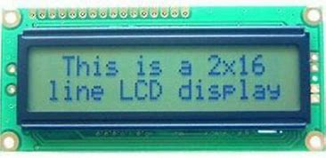

Figure 9 : LCD Display

Liquid Crystal Display (LCD) and the Internet of Things (IoT) are related in that LCDs are

often used as display devices for IoT devices and systems. For example, LCD screens can

be used to display real-time data from IoT sensors or to provide a user interface for

controlling IoT devices.

* **RF TECHNOLOGY**



Figure 10 : RF Technology

* A Radio Frequency signal refers to a wireless electromagnetic signal used as a form of communication .
* Radio waves are a form of electromagnetic radiation with identified radio frequencies that range from 3kHz to 300GHz .
* **CONNECTIVITY**

IoT devices rely on various communication protocols and networks to transmit data to other devices or cloud platforms. Common connectivity options include Wi-Fi, cellular networks, Bluetooth, Zigbee, LoRaWAN, and MQTT (a messaging protocol).

* **GATEWAYS**

Gateways serve as intermediaries between IoT devices and the cloud or central servers. They aggregate data from multiple devices, perform data preprocessing, and transmit the data to the cloud. Gateways often serve as a bridge between different communication protocols.

* **CLOUD PLATFORMS**

Cloud platforms provide the infrastructure for data storage, processing, and analysis. They enable scalable and secure data management, as well as the ability to remotely monitor and control IoT devices. Popular cloud platforms for IoT include AWS IoT, Microsoft Azure IoT, and Google Cloud IoT.

* **DATA ANALYTICS AND MACHINE LEARNING**

IoT generates vast amounts of data. Data analytics and machine learning tools are used to process, analyze, and derive insights from this data. Predictive maintenance, anomaly detection, and optimization are common use cases.

These components work in concert to create the interconnected ecosystem that characterizes the Internet of Things, enabling a wide range of applications across industries such as healthcare, agriculture, smart cities, transportation, and industrial automation

**CHAPTER 4**

### **SCOPE OF INTERNET OF THINGS(IOT)**

* **Industry and Manufacturing:**

IoT is revolutionizing industries like manufacturing, agriculture, and logistics by enabling real-time monitoring of equipment, supply chains, and production processes. This leads to increased efficiency, reduced downtime, and cost savings.

* **Smart Cities:**

IoT is being used to create smarter and more efficient cities. Applications include smart traffic management, waste management, energy-efficient street lighting, and improved public transportation systems.

* **Healthcare**

IoT devices, such as wearable fitness trackers and medical sensors, are helping individuals monitor their health. Additionally, IoT is being used in healthcare facilities for asset tracking, patient monitoring, and medication management.

* **Smart Homes**

IoT is making homes more convenient and energy-efficient. Smart thermostats, lights, security systems, and appliances can be controlled remotely, saving energy and enhancing security.

* **Transportation and Logistics**

IoT is transforming transportation with applications like fleet management, vehicle tracking, and predictive maintenance. In logistics, it's used for real-time tracking of shipments and optimizing supply chain operations.

* **Agriculture**

IoT sensors and devices are used in precision agriculture to monitor soil conditions, weather, and crop health, leading to more efficient farming practices and increased yields.

* **Environmental Monitoring**

IoT is crucial for monitoring and addressing environmental issues such as air and water quality, climate change, and natural disaster detection.

* **Retail**

IoT is used to enhance the customer shopping experience through personalized marketing, inventory management, and store analytics.

* **Energy Management**

IoT plays a significant role in optimizing energy consumption in industries, buildings, and homes, contributing to energy conservation and cost reduction.

* **Education**

IoT is used in educational settings for smart classrooms, remote learning solutions, and tracking student attendance and performance.

**CHAPTER 5**

## STEPS TO BUILD A PROJECT USING ARDUINO

Building a website using Arduino may not be a typical approach, as Arduino is a microcontroller platform primarily designed for hardware and embedded systems. However, you can create a web-based interface to interact with your Arduino projects and sensors using additional components and technologies. Here are the steps to build a basic web-based interface for Arduino projects

**Materials and Components Needed :**

1. Arduino board (e.g., Arduino Uno, Arduino Mega, ESP 8266)
2. Sensors or actuators (e.g., temperature sensor, LED, servo motor)
3. Breadboard and jumper wires
4. USB cable for Arduino
5. Computer with Arduino IDE installed
6. Internet connection

**Steps :**

* **Prepare Your Arduino Setup**

Set up your Arduino board and connect the sensors or actuators you want to control or monitor. Write the Arduino code to read sensor data or control your hardware based on input.

* **Install Appropriate Libraries**

Depending on your project, you might need additional libraries to connect your Arduino to the internet. Common libraries include Ethernet or Wi-Fi libraries for network connectivity.

* **Connect Arduino to the Internet**

If you are using Ethernet, connect your Arduino to your local network using an Ethernet shield or module. For Wi-Fi, use a Wi-Fi shield or module. Configure the network settings and test the connectivity.

* **Create a Web Page**

You will need to create an HTML web page that serves as the user interface for your Arduino project. You can use a simple text editor or a web development tool to create the HTML, CSS, and JavaScript code for your web page.

* **Interface Design**

Design the web interface elements such as buttons, sliders, or text fields that will allow users to interact with your Arduino project. Use HTML for structure, CSS for styling, and JavaScript for functionality.

* **Arduino Web Server**

Write Arduino code to create a simple web server. This code should handle incoming HTTP requests and responses. For example, you can use the EthernetServer or WiFiServer libraries to listen for incoming requests.

* **Web Page Hosting**

You need a place to host your web page. You can use a hosting service or set up a local server on your computer. Ensure that your Arduino can access this web page.

* **Data Exchange**

Implement the communication between your web page and the Arduino. Use AJAX or WebSocket to send data from the web page to the Arduino and receive updates or responses.

* **Test and Debug**

Test your setup by accessing the web page from a computer or mobile device. Check for any issues with connectivity, data exchange, or the user interface.

* **Refine and Expand**

Depending on your project's complexity, you may want to add more features, security measures, or optimize the code.

* **Publish Your Web Page**

If you're satisfied with your project, you can publish your web page online, making it accessible from anywhere with an internet connection.

**CHAPTER 6**

**MINI PROJECT**

***PROJECT – BLIND SPECS***



Figure 11 : Smart Specs

**Components Required:**

* + ESP-8266
  + ULTRA SONIC SENSOR
  + IR SENSOR
  + ACCELEROMETER SENSOR
  + BUZZER
  + JUMPING WIRES

### **Product Details:**

* + Our main objective of the project is to solve the identified problem statement , By the modern IoT Tech By Our Theme, Smart Werables

-Smart Specs

-Smart Shoes

-Smart Locket

* + We need blind people To Walk easily in the public places with our smart wearables , Avoid Injuries and accidents .
  + And Also sends and SOS alert to a person close to them , If they sense a threat.
  + Smart Wear Should replace the traditional Blind Stick. So that They don’t feel embraced in Public places. Get Differentiated in the Public Places .

**Circuit diagram :**

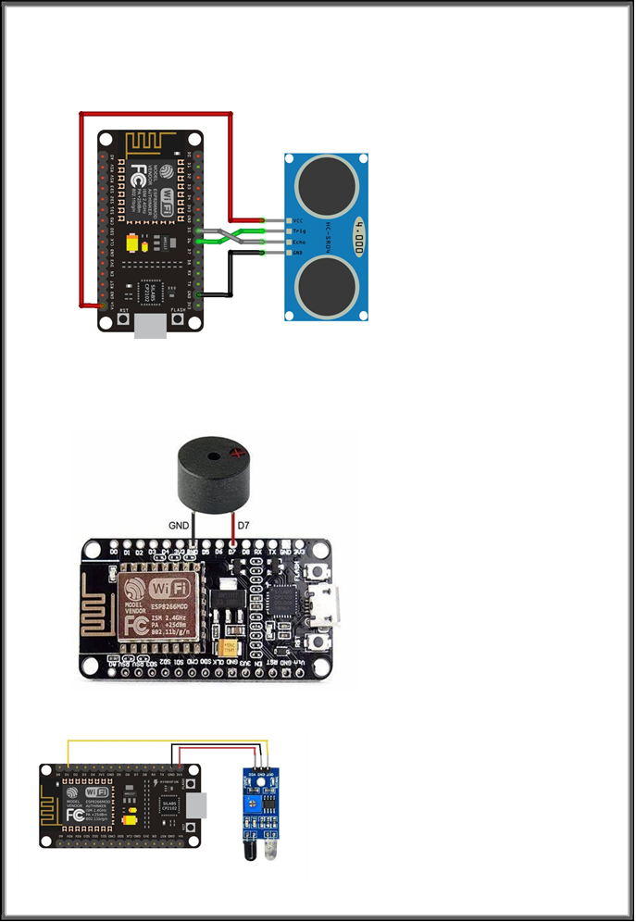

ESP8266 TO IR SENSOR

ESP 8266 TO BUZZER

ESP 8266 TO BUZZER

ESP 8266 TO BUZZER

ESP 8266 TO ULTRASONIC SENSOR

**Code:**

// Include the required libraries #include <NewPing.h>

// Define the pins for the ultrasonic sensor #define TRIGGER_PIN 5

#define ECHO_PIN 4

// Define the pin for the buzzer #define BUZZER_PIN 0

// Define the maximum distance for triggering the buzzer #define MAX_DISTANCE 100

#include <SoftwareSerial.h> #include <ESP8266WiFi.h> #include <WiFiClient.h>

#include <ESP8266WebServer.h>

// Replace with your Twilio account details

const char* TWILIO_ACCOUNT_SID = "AC170bd559b79e993774712e92989ded65"; const char* TWILIO_AUTH_TOKEN = "331f3c8888baa9370d70ebdca819dc9e";

// Replace with your Twilio phone number and destination phone number const char* TWILIO_PHONE_NUMBER = "+12545275333";

const char* DESTINATION_PHONE_NUMBER = "7259401148";

SoftwareSerial mySerial(2, 3);

// RX, TX

// Create an instance of the NewPing library NewPing sonar(TRIGGER_PIN, ECHO_PIN);

void setup() {

// Initialize the serial communication Serial.begin(115200); mySerial.begin(9600);

delay(1000);

// Connect to Wi-Fi network connectWiFi();

// Wait for the module to connect to Twilio delay(2000);

// Set the buzzer pin as an output pinMode(BUZZER_PIN, OUTPUT);

}

void loop() {

// Perform a sonar distance measurement

int distance = sonar.ping_cm()

// Check if the distance is less than the maximum distance

if(distance<MAX_DISTANCE)

{ digitalWrite(BUZZER_PIN, HIGH);

delay(10000);

sendSMS("emergency");

delay(5000); // Wait for 5 seconds before sending the next SMS

}

else {

// Turn off the buzzer digitalWrite(BUZZER_PIN, LOW);

}

// Print the measured distance to the serial monitor Serial.print("Distance: ");

Serial.print(distance); Serial.println(" cm");

// Delay before the next measurement delay(1000);

}

void sendSMS(const char* message) { mySerial.println("AT+CMGF=1");

// Set the GSM module to text mode

delay(1000);

mySerial.print("AT+CMGS=\""); mySerial.print(7259401148); mySerial.println("\"");

delay(1000);

mySerial.print(message); delay(100);

mySerial.println((char)26); // End the SMS by sending Ctrl+Z

delay(5000); // Wait for the SMS to be sent Serial.println("SMS sent!");

}

void connectWiFi() {

// Replace with your Wi-Fi SSID and password const char* WIFI_SSID = "TestA";

const char* WIFI_PASSWORD = "Jittest@a";

Serial.print("Connecting to "); Serial.println(WIFI_SSID);

while (WiFi.status() != WL_CONNECTED) { delay(1000);

Serial.print(".");

}

Serial.println(""); Serial.println("WiFi connected"); Serial.println("IP address: "); Serial.println(WiFi.localIP());

}

**CHAPTER 7**

**CONCLUSION**

In conclusion, my internship experience in the field of Internet of Things (IoT) has been both enhancing and enriching. Throughout this internship, I had the opportunity to work on a unique range of projects, gaining hands-on experience in designing, developing, and implementing IoT solutions. The Internet of Things (IoT) represents a transformative and rapidly evolving technological landscape that has already had a profound impact on various industries and aspects of our daily lives. It has ushered in a new era of connectivity, automation, and data-driven decision-making. Here are some key takeaways and concluding thoughts about IoT.

I learned how IoT technologies are shaping industries, improving efficiency, and enhancing the quality of life. This internship has not only helped me in learning a new skill but also has left the impact to learn more about it. And also learnt my ability to work in a collaborative team environment, communicate effectively, and solve real-world problems.

Moreover, I have gained valuable insights into the challenges and opportunities that exist in the IoT field. This experience has not only solidified my passion for this field but has also equipped me with the knowledge and skills to pursue a career in IoT with the best knowledge.

I would like to express my gratitude to Tequed labs and my mentors, for their guidance, support, and encouragement throughout this internship. This valuable experience will undoubtedly serve as a foundation for my future endeavors in the world of IoT.

In summary, IoT is a dynamic and transformative technology that is reshaping industries, improving efficiency, and enhancing our daily lives. Its continued growth and success will depend on addressing challenges, ensuring security and privacy, fostering collaboration among stakeholders, and leveraging emerging technologies. As IoT continues to evolve, its impact on society and the economy is likely to be profound, making it an area of continued importance and innovation.

This internship has been an enlightening journey, and I am looking forward to implement the skills gained for the technologies in the future.

**CHAPTER 8**

**REFRENCES**

* [**IoT Based Heartbeat Monitoring System using NodeMCU**](https://iotdesignpro.com/projects/iot-based-heartbeat-monitoring-system-using-nodemcu)
* [**IoT in Healthcare: Challenges, Benefits With Examples**](https://www.westagilelabs.com/blog/iot-in-healthcare-challenges-benefits-with-examples/)
* “The Internet of Things” by Samuel Greengard
* “The Fourth Industrial Revolution” by Klaus Schwab
* “Getting started with Internet of Things” by Cuno Pfister
* <https://www.google.com/>
* [**https://www.researchgate.net/publication/343631281_IoT_based_System_for_Heart_Rate_**](https://www.researchgate.net/publication/343631281_IoT_based_System_for_Heart_Rate_)

**Monitoring**